Developing a theory of change with a biodiversity focus resource

**Contents**

Contents 2

Stage 2a: 6

Define the key habitats and ecosystem 7

Stage 2b: Analyse the wider context 8

Stage 3: Map stakeholders 19

Stage 4: Assess team and understand external factors 22

Stage 5: Understand the threats and problems 23

Map out the direct threats to each of the project’s key species or habitats/ecosystems. Continue the tree below. 24

Stage 7: Develop a Theory of Change diagram and narrative 28

Checklist 30

**Stage 1:**

|  |  |
| --- | --- |
| **Question** | **Answer(s)** |
| What end point is your project aiming for? |  |
| What is the main conservation problem you are seeking to tackle? |  |
| What is the scale/scope of our project? |  |
| What is appropriate for the resources the project is likely to have? |  |
| Are you focusing on any specific habitats/species? |  |
| How long would the change you’re talking about take? |  |

|  |
| --- |
| **Vision Statement** |
|  |

**Stage 2a:**

**Key species**

|  |  |
| --- | --- |
| **Question** | **Answer(s)** |
| Is anyone else or any other organisation working with this species? |  |
| Where are they found?  Is this area protected?  If so, who is responsible? |  |
|  |
|  |
| What kinds of habitats are they found in? |  |
| What key threats to that species are there? |  |
| How does their life history relate to your area |  |
| How many are there?  Globally?  In your area? |  |
|  |
|  |
| What do they eat? |  |
| What is their reproductive age? |  |
| Do they have particular behavioural traits? |  |
| What is their protection status in your area? |  |
| Are these species harvested / used?  If so, who by?  Are they important for local livelihoods? |  |
|  |
|  |
| Are there any cultural values related to these species? |  |

Stage 2a:

Define the key habitats and ecosystem

|  |  |
| --- | --- |
| **Question** | **Answer(s)** |
| Is anyone else or any other organisation working on this environment? |  |
| What are the key ecosystem features? E.g. biotic or a biotic factors? |  |
| What key threats to the habitat/ecosystem are there? |  |
| Are there different habitat types that are important for biodiversity?  If so, where are they? |  |
|  |
| Do these places provide particular ecosystem services? |  |
| Is the area under any form of protection?  What are the boundaries?  Who is responsible? |  |
|  |
|  |
| What are the land / sea tenure arrangements for the site(s)? |  |
| Are there jurisdictional boundaries that affect the area? |  |
| How are the habitats / ecosystems used? who by? |  |
| Are there any cultural values placed on the site? |  |

**Stage 2b: Analyse the wider context**

***Political***

|  |  |
| --- | --- |
| **Question** | **Answer(s)** |
| What government policies or political groups could be beneficial or detrimental to the project? |  |
| Is the political environment stable or likely to change?  When is the next local or national election?  Who are the most likely contenders for power?  How might this change policies and affect the project? |  |
|  |
|  |
|  |
| Who are the key government stakeholders?  Do you have an existing relationship with them, and if so, what is this relationship like? |  |
|  |
| Are there key stakeholders you do not have an existing relationship with?  Is there an appropriate way to approach them |  |
|  |

***Economic***

|  |  |
| --- | --- |
| **Question** | **Answer(s)** |
| What economic factors could impact the project moving forward? |  |
| What types of livelihood strategies do people who might be impacted by our project engage in?  Is there variability based on time of year?  Is there a time of year when people experience greater livelihood vulnerability?  How does this impact people? |  |
|  |
|  |
|  |
| How stable is the current economy?  Is it growing, stagnating or declining?  How is globalisation affecting the economic environment? |  |
|  |
|  |
| Are the key exchange rates stable or do they tend to vary significantly? |  |
| What is the unemployment rate? |  |

***Social***

|  |  |
| --- | --- |
| **Question** | **Answer(s)** |
| Are there different ethnic groups within the population?  Do different ethnic groups have different levels of political influence?  Do different ethnic groups have different values and interests in the environment?  Are there any considerations about which groups the project engages with and how? |  |
|  |
|  |
|  |
| Are there any Indigenous Peoples in the project area?  If so, how will they be engaged, and how could the project impact them (positively and negatively)? |  |
|  |
| Are there vulnerable or historically marginalised groups (including unregistered peoples) in the project area?  How could these groups be impacted (positively and negatively) by the project?  What steps will the project take to engage with these peoples and ensure their perspectives and values are heard and accounted for? |  |
|  |
|  |
| What is the population’s growth rate and age profiles?  How likely is this to change? |  |
|  |
| Are generational shifts in attitude likely to affect the project? |  |
| What are the society’s level of health, education and social mobility?  How are these changing? What impact does this have? |  |
|  |
| What are the attitudes and perceptions towards different work and livelihood activities?  Are these different for different members of the population (age, gender, ethnicity, class, educational status etc.) |  |
|  |
| What social attitudes and social taboos could affect the project? |  |
| Have there been recent socio-cultural changes that might affect this? |  |
| What religious and spiritual beliefs and lifestyle choices do we need to consider?  How might these affect our project? |  |
|  |
| Are there non-monetary values associated with resource-use and livelihoods? |  |
| What are gender roles and relations, including for uses and value of natural environments? |  |

***Technological***

|  |  |
| --- | --- |
| **Question** | **Answer(s)** |
| Do you avoid using technology? |  |
| Do any of your peers/stakeholders/competitors have access to new technologies that could affect the implementation of the project? |  |
| Have infrastructure changes affect our project? |  |

***Legal***

|  |  |
| --- | --- |
| **Question** | **Answer(s)** |
| Are there any changes to legislation that will happen in the next 2-4 years? |  |
| Do people in or near the project area have tenure (including customary) and resource-use rights that determine the conditions for access, use, and management of the environment? |  |
| How widespread are corruption and organised crime?  How are these situations likely to change and how is that likely to affect the project? |  |
|  |
| What is the likely timescale of any proposed legislative changes?  Is there an opportunity for the project to influence or be involved in this? |  |
|  |
| How do we ensure we are compliant with relevant laws? |  |
| Could any pending legislation or taxation changes affect the project, positively or negatively? |  |
| How does the government approach Corporate Social Responsibility, environmental issues, corporate policy and customer protection legislation?  What impact does this have and is it likely to change? |  |
|  |

***Environmental***

|  |  |
| --- | --- |
| **Question** | **Answer(s)** |
| How does the physical environment affect the project? |  |
| Are there natural resources in the project area that people rely on for their livelihoods?  What is the condition of these? |  |
|  |
| What are the effects of climate, weather or geographical location on the project?  How will climate change or natural disaster impact the project now and in the future? |  |
|  |
| Are we prepared for future local/national and global environmental targets or laws? |  |
| Could the project negatively impact the environment in any way?  How do we mitigate this or stay aligned to what we believe in? |  |
|  |
| How can we source, trade and test our products in an environmentally conscious way? |  |

**Stage 3: Map stakeholders**

**Step1: Brainstorm the different stakeholders in your project.**

Stakeholders

**Step 2 Identify rightsholders and potential rightsholders**

Rightsholders

**Step 3 Identify key partners**

|  |  |  |  |  |
| --- | --- | --- | --- | --- |
| Person or organization | Shareholder or Rightsholder (or both) | Are they working to tackle the threats your project wants to address? How? | Could they be influential in your project? | Could they be affected by the project? |
|  |  |  |  |  |
|  |  |  |  |  |
|  |  |  |  |  |
|  |  |  |  |  |
|  |  |  |  |  |
|  |  |  |  |  |
|  |  |  |  |  |

**Stage 4: Assess team and understand external factors**

**Internal**

**Negative**

**Positive**

|  |  |
| --- | --- |
| **STRENGTHS** | **WEAKNESSES** |
| **OPPORTUNITIES** | **CONSTRAINTS** |

**External**

**Stage 5: Understand the threats and problems**

Map out the direct threats to each of the project’s key species or habitats/ecosystems. *Continue the tree below.*

How significant is each of these threats to your biodiversity target?

*Threat ranking*

|  |  |  |  |  |  |
| --- | --- | --- | --- | --- | --- |
| ***Direct threat*** | ***Scope of impact*** | ***Severity of impact*** | ***Irreversibility of impact*** | ***Final assessment*** | ***Total score*** |
|  |  |  |  |  |  |
|  |  |  |  |  |  |
|  |  |  |  |  |  |
|  |  |  |  |  |  |
|  |  |  |  |  |  |
|  |  |  |  |  |  |

**Stage 6: Develop a solution tree**

**Option 1. Backwards mapping**

Using the threat tree developed in stage 6, go through each direct threat and turn them into a positive statement i.e. when the problem is solved.

|  |  |
| --- | --- |
| Outcomes | Will you address this problem within your project? |
|  |  |
|  |  |
|  |  |
|  |  |
|  |  |
|  |  |
|  |  |

**Option 2. Forwards mapping from potential interventions**

Rather than directly mapping solutions to the threats and drivers unpacked in stage 6, you can initially review the threats as a whole and note down any interventions that they think of as well as combine with any that they had in mind already.

Next plot out how you would expect each intervention to achieve the desired impact:

* starting from the direct output for what that intervention would achieve,
* followed by what outcome that output would cause,
* and finally how that outcome would achieve the overall impact

**Reviewing the solution tree**

Whether you did option 1 or 2, it is important that teams prioritise which activities the project should take forward. This depends on:

* the likelihood of the activity solving the problem
* the likelihood of the project team being able to implement that activity
* if other stakeholders are already implementing that activity

**Reviewing the solution tree**

|  |  |
| --- | --- |
| Activity | High priority? |
|  |  |
|  |  |
|  |  |
|  |  |
|  |  |
|  |  |
|  |  |
|  |  |
|  |  |
|  |  |
|  |  |
|  |  |
|  |  |
|  |  |

**Stage 7: Develop a Theory of Change diagram and narrative**

*Step 1- Clarify your impact statement*

|  |
| --- |
| **Vision Statement** |
|  |

*Step 2- Test the logic and check assumptions*

Once you have plotted out how each activity will create the intended impact, each chain should be reviewed to check the logic is correct and capture what assumptions we are making at each step.

For both the impact pathways and the assumptions, consider:

* Why did we think that ‘x’ will lead to ‘y’? What makes us think that?
* What might hinder this from happening (e.g. costs, opposing views, lack of trust/capacity/technology, people losing assets, etc)?
* What are the gaps in our ToC? Are there any missing links (that we can influence)?
* Who else might need to be involved? Who else can we connect with who can aid in our progress towards our desired impact?
* Looking at the pathways again, are there better ways of getting to our goal?

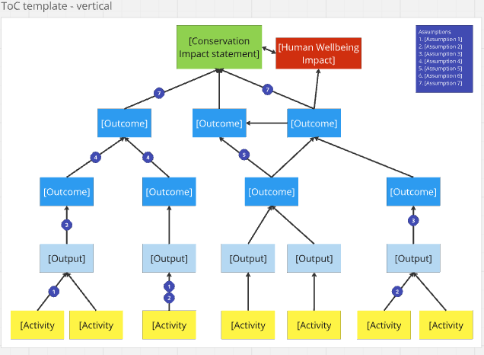

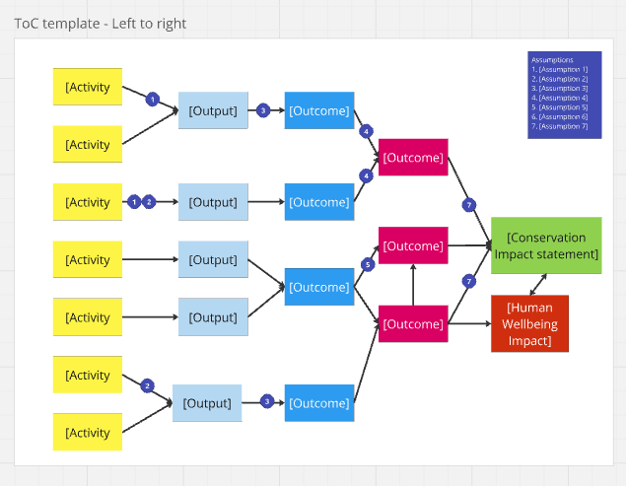

**Checklist**

|  |  |  |
| --- | --- | --- |
| Stage | Outcome | Finished? |
| 1 | A broad statement of the potential vision for the project, that everyone in the room can live with. |  |
| 2 | A list of key species, habitats or ecosystems |  |
| 2 | A map of where key species, habitats or ecosystems are |  |
| 2 | A list of considerations from the wider context that may affect the design and implementation of the project. |  |
| 3 | List of key stakeholders with understanding of their influence and stake in the project’s activities and impact. |  |
| 4 | Lists of the strengths and weaknesses of the team, and lists of the opportunities and constraints that the project should consider when developing and designing a project. |  |
| 5 | A diagram showing the root causes of threats/problems |  |
| 6 | A solution tree for how the project will achieve its vision |  |
| 6 | A list of possible solutions that address the threats |  |
| 6 | A prioritised list of activities that could be implemented by the project |  |
| 7 | A ToC diagram and narrative |  |
|  |  |  |
| Review stage | A ToC that continues to be relevant and logical |  |
| Simplifying | A ToC that continues to be understandable and usable |  |